INTERNSHIP PROJECT REPORT
ON
Threat Intelligence Aggregator (Non-AI)
Submitted as part of the Cyber Security Internship Program

Internship Period
December 2025 – June 2026

Supervised By: Submitted By:
Mr. Harshit Ravi
Organization:
Unified Mentor

INDEX

Sr. No. | Title | Page No.
1. | Abstract | 4
2. | Introduction | 5-6
3. | Problem Statement | 7
4. | Project Objective | 8
5. | Scope of the Project  - 5.1 In Scope  - 5.2 Out of Scope | 9
6. | Tools & Technologies Used | 10
7. | Methodology / Workflow | 11-12
8. | Implementation Details | 13-17
9. | Results & Findings | 18
10. | Security Recommendations | 19
11. | Learning Outcomes | 20
12. | Conclusion | 21
13. | Future Enhancements | 22
14. | References | 23

List of Figures

Figure No. | Description | Page No.
Figure 7.1 | System Workflow Diagram | 12
Figure 8.1 | Normalized IOC Data Output | 14
Figure 8.2 | Corelated IOC Data with Risk Levels | 15
Figure 8.3 | Generate Blocklist File | 16
Figure 8.4 | Project Execution in Terminal | 17

1. ABSTRACT
The Threat Intelligence Aggregator (Non-AI) is a cybersecurity-based project designed to collect, process, and analyze threat intelligence data from multiple heterogeneous sources. In modern cybersecurity environments, organizations receive large volumes of threat intelligence feeds containing Indicators of Compromise (IOCs) such as malicious IP addresses, domains, URLs, and file hashes. These feeds are often distributed in different formats such as CSV, TXT, and JSON, making manual analysis inefficient and time-consuming.
The primary objective of this project is to develop a unified system that can automatically parse, normalize, and correlate threat intelligence data without the use of artificial intelligence or machine learning techniques. The system focuses on rule-based processing and pattern matching to extract relevant indicators using regular expressions. Once extracted, the data is normalized into a structured format to ensure consistency across different sources.
A key feature of the project is the correlation engine, which identifies repeated indicators across multiple feeds. Indicators that appear multiple times are considered high-risk, as they are more likely to represent active threats. Based on this analysis, the system assigns risk levels to each indicator and prioritizes them accordingly. This helps in reducing noise and focusing on critical threats.
The project also includes a blocklist generation module, which creates categorized lists of high-risk indicators such as IP blocklists, domain blocklists, and URL blocklists. These blocklists can be directly used by security tools such as firewalls, intrusion detection systems (IDS), and endpoint protection systems to proactively block malicious activity.
Additionally, the system generates a final report summarizing the processed data, including total indicators, unique indicators, and high-risk detections. This report provides a clear overview of the threat landscape and supports decision-making in security operations.
Overall, this project provides practical exposure to real-world threat intelligence workflows, including data collection, parsing, normalization, correlation, and reporting. It demonstrates how automated systems can enhance cybersecurity defenses by transforming raw threat data into actionable intelligence.

2. INTRODUCTION
The rapid growth of digital technologies and internet-based services has significantly increased the risk of cyber threats and attacks. Organizations across the world are continuously targeted by malicious actors who exploit vulnerabilities in systems and networks. To defend against such threats, cybersecurity professionals rely heavily on threat intelligence, which provides information about potential or existing cyber threats. Threat intelligence plays a crucial role in identifying, analyzing, and mitigating cyber risks before they cause serious damage.
Threat intelligence data is typically collected from multiple sources, including open-source intelligence (OSINT), security vendors, internal system logs, and threat-sharing platforms. These sources provide valuable information in the form of Indicators of Compromise (IOCs), such as suspicious IP addresses, malicious domains, harmful URLs, and other artifacts related to cyber attacks. However, one of the major challenges faced by organizations is that this data is often unstructured and available in different formats like TXT, CSV, and JSON files. This lack of uniformity makes it difficult to analyze and utilize the data effectively.
Another significant issue is the large volume of data generated from these sources. Security analysts often struggle to manually process and analyze such large datasets within a limited time. As a result, important threats may go unnoticed, leading to potential security breaches. Therefore, there is a need for an automated system that can efficiently process and analyze threat intelligence data in a structured and systematic manner.
The Threat Intelligence Aggregator (Non-AI) project is designed to address these challenges by providing a simple yet effective solution for collecting, processing, and analyzing threat intelligence data. The system focuses on automating key steps such as data parsing, normalization, and correlation without relying on complex artificial intelligence or machine learning techniques. Instead, it uses rule-based methods and pattern matching to extract relevant information from raw data.
The first step in the system is data collection and parsing. The project supports multiple file formats, specifically TXT and CSV files, which are commonly used for sharing threat intelligence feeds. Using regular expressions, the system scans the input data and extracts important indicators such as IP addresses, domain names, and URLs. This automated extraction process reduces manual effort and ensures accuracy in identifying relevant data.
Once the data is extracted, the next step is normalization. Normalization involves converting the extracted data into a consistent and structured format. Each indicator is represented with attributes such as type, value, and source. This standardization makes it easier to store, process, and analyze the data across different sources without confusion or duplication issues.
After normalization, the system performs correlation, which is one of the most important aspects of threat intelligence analysis. The correlation engine compares indicators from multiple sources and identifies repeated occurrences. Indicators that appear more than once are considered more suspicious and are assigned a higher risk level. This helps in prioritizing threats and focusing on the most critical indicators that require immediate attention.
In addition to correlation, the project also includes a blocklist generation feature. Based on the risk levels assigned to the indicators, the system generates separate blocklists for IP addresses, domains, and URLs. These blocklists can be integrated with security tools such as firewalls and intrusion detection systems to block malicious traffic and prevent cyber attacks.
The system also provides a reporting mechanism that summarizes the analysis results. The report includes information such as the total number of indicators processed, the number of unique indicators, and the number of high-risk indicators detected. This summary helps security analysts understand the overall threat landscape and make informed decisions.
One of the key advantages of this project is its simplicity and practicality. By avoiding the use of complex AI-based models, the system remains lightweight, easy to understand, and suitable for beginners in cybersecurity. At the same time, it demonstrates important real-world concepts such as threat data processing, indicator correlation, and risk analysis.
Furthermore, the project can be easily extended in the future by adding support for additional file formats, integrating external threat intelligence APIs, or incorporating advanced analytics techniques. This makes it a scalable and flexible solution for cybersecurity applications.
In conclusion, the Threat Intelligence Aggregator (Non-AI) provides an efficient approach to handling and analyzing threat intelligence data. It simplifies the process of converting raw data into actionable insights, thereby improving the overall effectiveness of cybersecurity operations. The project not only enhances technical understanding but also provides practical experience in building real-world security solutions.

3. PROBLEM STATEMENT
In the modern digital landscape, organizations are increasingly dependent on threat intelligence to identify and mitigate cyber threats. However, one of the major challenges faced by cybersecurity teams is the effective handling of large volumes of threat intelligence data collected from multiple sources. These sources, such as open-source feeds, security tools, and internal logs, provide data in various formats including TXT, CSV, and other structured or semi-structured files. The lack of a standardized format makes it difficult to analyze and utilize this data efficiently.
Another critical issue is the inconsistency and redundancy present in threat intelligence feeds. The same Indicators of Compromise (IOCs), such as IP addresses, domain names, and URLs, may appear across different sources. Without proper correlation mechanisms, it becomes difficult to identify which indicators are more significant or potentially harmful.
Manual processing of such data is time-consuming and prone to human error. Security analysts often have to manually extract, filter, and analyze indicators, which not only reduces efficiency but also increases the chances of missing critical threats. Additionally, the absence of an automated system for normalization results in inconsistent data representation, further complicating the analysis process.
Another problem is the lack of a simple and lightweight system that can perform threat intelligence aggregation without relying on complex artificial intelligence or machine learning models. While advanced systems exist, they are often resource-intensive and require specialized knowledge, making them unsuitable for beginners or small-scale implementations.
Furthermore, without proper risk classification, it becomes difficult to distinguish between low-risk and high-risk indicators. This can lead to ineffective decision-making and delayed response to critical threats. The absence of automated blocklist generation also limits the ability to quickly implement preventive security measures.
Therefore, there is a need for a system that can automatically collect, parse, normalize, and correlate threat intelligence data from multiple sources in a structured manner. Such a system should be capable of identifying repeated indicators, assigning risk levels, and generating actionable outputs such as blocklists. The solution should be simple, efficient, and independent of complex AI-based techniques.

4. PROJECT OBJECTIVES
The main objective of the Threat Intelligence Aggregator (Non-AI) project is to develop a system that can efficiently collect, process, and analyze threat intelligence data from multiple sources. The system focuses on handling Indicators of Compromise (IOCs) such as IP addresses, domain names, and URLs by converting unstructured data into a structured format.
One of the key objectives is to design a data parsing mechanism that can extract relevant indicators from different file formats, specifically TXT and CSV files. This helps in handling heterogeneous data sources and ensures accurate extraction using regular expressions.
Another important objective is to normalize the extracted data into a consistent structure. Each indicator is represented with attributes such as type, value, and source. This standardization removes inconsistencies and simplifies further processing and analysis.
The project also aims to implement a correlation mechanism to identify repeated indicators across multiple sources. Indicators that appear more than once are considered more suspicious and are prioritized for further analysis.
Assigning risk levels to indicators is another objective of the system. Indicators with multiple occurrences are classified as high-risk, while others are marked as low-risk. This helps in improving threat prioritization and decision-making.
The system also focuses on generating blocklists based on high-risk indicators. Separate blocklists are created for IP addresses, domains, and URLs, which can be used by security tools to prevent malicious activities.
Additionally, the project aims to provide a simple reporting mechanism that displays normalized data, correlated results, and risk levels. This helps users understand the overall threat data clearly and efficiently.
Finally, the project is designed to be simple and lightweight without using artificial intelligence or machine learning techniques. It provides practical knowledge of threat intelligence processing and helps in understanding real-world cybersecurity workflows. The system is easy to implement and can be extended in the future for advanced features.

5. SCOPE OF THE PROJECT
The scope of the Threat Intelligence Aggregator (Non-AI) project defines the boundaries and functionalities of the system in terms of what it includes and what it does not cover. The project focuses on building a simple and efficient system to process and analyze threat intelligence data without the use of advanced artificial intelligence techniques. It mainly deals with handling Indicators of Compromise (IOCs) such as IP addresses, domain names, and URLs obtained from different data sources.
5.1 In-Scope
The system is designed to support the collection and processing of threat intelligence data from multiple file formats, specifically TXT and CSV files. It includes a parsing mechanism that extracts relevant indicators using pattern matching techniques such as regular expressions. This allows the system to automatically identify IOCs from raw data without manual intervention. The project includes a normalization module that converts extracted data into a structured format with defined attributes such as type, value, and source.
The project also includes the generation of blocklists for IP addresses, domains, and URLs. These blocklists are based on high-risk indicators and can be used by security tools to prevent malicious activities. Additionally, the system provides a simple output report that displays normalized data and correlated results for analysis.
5.2 Out-Scope
The project does not include the use of artificial intelligence or machine learning algorithms for threat detection or prediction. It is designed as a rule-based system to keep it simple and easy to understand.
The system does not support live data fetching from external threat intelligence APIs or real-time data streams. It works only with static input files provided by the user. Integration with enterprise-level security systems such as SIEM platforms is also outside the scope of this project.
Furthermore, the project does not include a graphical user interface (GUI) and operates through a command-line interface. It is intended for demonstration and educational purposes rather than deployment in large-scale production environments.
6. Tools & Technologies Used
The Threat Intelligence Aggregator (Non-AI) project uses a combination of simple and effective tools and technologies to process and analyze threat intelligence data. These tools are selected to ensure ease of implementation, efficiency, and clarity in understanding cybersecurity concepts.
1. Programming Language:- Python is used as the main programming language for developing the system. It is simple, readable, and widely used in cybersecurity projects. It supports fast development and easy handling of data processing tasks.
2. Python Libraries
- re (Regular Expressions): Used for pattern matching and extracting IOCs such as IP addresses, URLs, and domains. Helps in automating the detection of indicators from raw data.
- csv Module: Used for reading and processing CSV files efficiently. Enables handling of structured data from different sources.
3. Development Tools:- Visual Studio Code and Notepad++ are used for writing and editing the code. These editors provide features like syntax highlighting, debugging, and easy navigation. They improve coding efficiency and reduce errors during development.
4. Operating System:- The project is implemented on a Windows operating system. It provides compatibility with Python and supports file handling operations. The environment is easy to set up and use for development purposes.
5. Execution Environment: The system runs using a Command-Line Interface (CLI). Python scripts are executed through the terminal. This makes the system lightweight and easy to operate without a graphical interface.
6. Input Data Sources: The project uses sample TXT and CSV files as input data. These files simulate real-world threat intelligence feeds. They contain raw data from which IOCs are extracted.
7. Output Generation: The system generates normalized data and correlated results. It also creates blocklist files for IPs, domains, and URLs. These outputs can be used for further security analysis and implementation.
7. Workflow / Architecture
The Threat Intelligence Aggregator (Non-AI) project follows a structured workflow designed to efficiently collect, process, and analyze threat intelligence data from multiple sources. The architecture is modular, with clearly defined steps to ensure smooth operation and easy scalability. The system can be divided into the following main components:
1. Load IOC Feeds
- The system imports threat intelligence data from multiple sources, primarily TXT and CSV files.
- These files contain Indicators of Compromise (IOCs) such as IP addresses, domain names, and URLs.
- This module ensures that all available threat data is collected for processing.
2. Parse Indicators
- Extracts IPs, URLs, and domains using pattern matching with regular expressions.
- Automates the process of scanning raw data and identifies relevant indicators.
- Eliminates manual data extraction and reduces human error.
3. Normalize Data
- Converts extracted data into a structured format with attributes like type, value, and source.
- Ensures uniformity across different sources and prepares data for correlation.
- Handles duplicate removal and standardizes data representation.
4. Correlation Engine
- Compares indicators across multiple feeds to identify repeated occurrences.
- Assigns risk levels based on frequency: repeated indicators are marked as HIGH risk.
- Helps in prioritizing critical threats and focusing on high-risk indicators first.
5. Blocklist Generation
- Creates categorized blocklists for IP addresses, domains, and URLs.
- High-risk indicators are included in the blocklists for use in firewalls, IDS, and endpoint protection.
- Supports export to TXT or CSV formats for easy integration.
6. Reporting Module
- Generates a final report summarizing the processed threat intelligence.
- Includes total indicators, unique indicators, and high-risk indicators.
- Provides actionable insights for security teams to strengthen defensive measures.

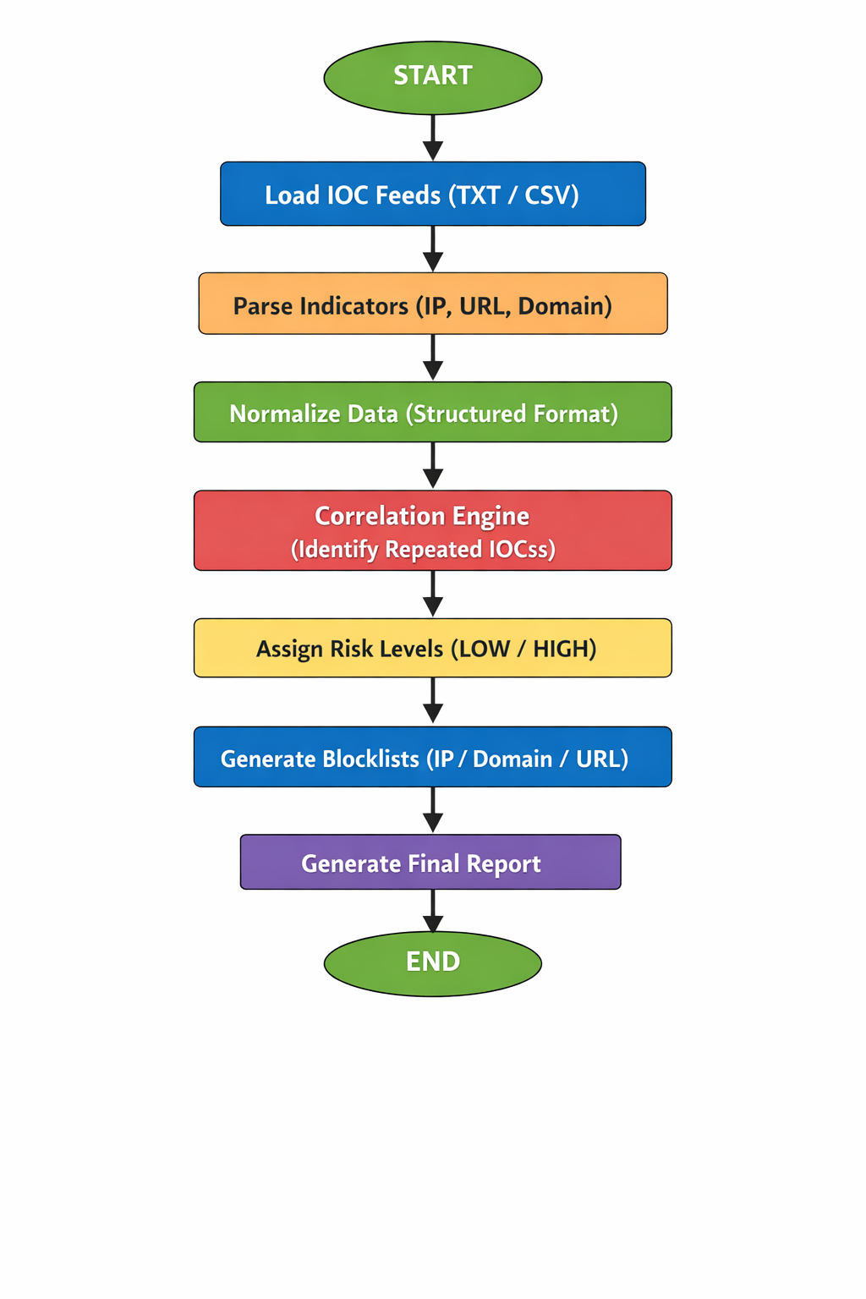

Fig 7.1 Workflow Diagram
- Implementation Details
The implementation of the Threat Intelligence Aggregator (Non-AI) project is carried out in a structured and systematic manner using Python. The system is designed to process raw threat intelligence data and convert it into meaningful and actionable output. The implementation focuses on multiple stages including data input, parsing, normalization, correlation, and blocklist generation.
1. Input Data Handling
The first step in the implementation involves collecting threat intelligence data from input files. The system reads TXT and CSV files stored in the feeds directory. These files simulate real-world threat intelligence feeds and contain unstructured data such as IP addresses, domain names, and URLs.
Python file handling techniques are used to open and read these files. The system ensures that data from multiple sources is loaded properly for further processing.
2. IOC Extraction (Parsing Module)
In this stage, the system extracts Indicators of Compromise (IOCs) using regular expressions. Separate parsing functions are implemented for TXT and CSV files.
- TXT files are processed by reading the entire content
- CSV files are processed row by row using the csv module
- Regular expressions are applied to identify IP addresses, URLs, and domain names
This automated extraction process eliminates manual effort and ensures accuracy in identifying relevant indicators.
3. Data Normalization
After extracting the IOCs, the system converts them into a structured format. Each indicator is stored as a dictionary containing:
- Type (IP / URL / DOMAIN)
- Value (actual indicator)
- Source (file name)
Normalization ensures that data from different sources is consistent and easy to analyze. It also helps in avoiding confusion caused by different data formats.
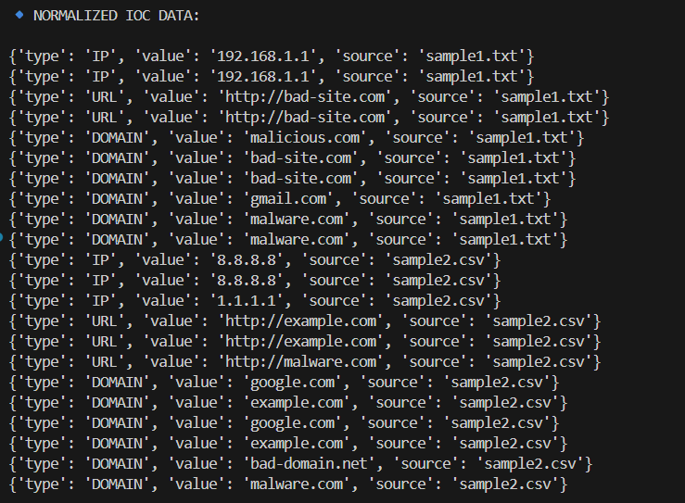
Figure 8.1: Normalized IOC Data Output

4. Correlation Engine
The correlation module is one of the most important parts of the system. It analyzes the normalized data and counts how many times each IOC appears across all sources.
- A dictionary-based approach is used for counting
- Repeated indicators are identified
- Frequency of each IOC is calculated
This process helps in detecting patterns and identifying indicators that are more likely to be malicious.

5. Risk Classification
After correlation, the system assigns risk levels to each indicator based on its frequency:
- Count = 1 → LOW risk
- Count > 1 → HIGH risk
This classification helps in prioritizing threats and focusing on indicators that require immediate attention.
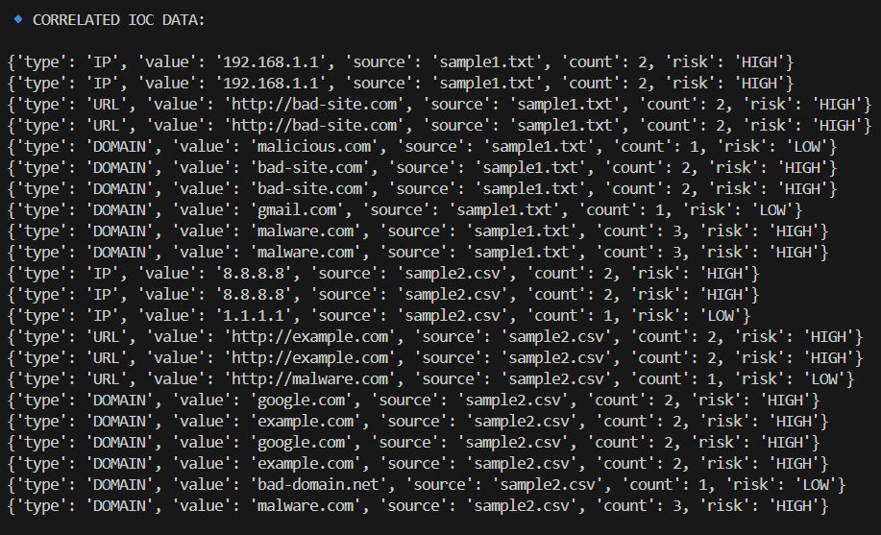
Figure 8.2: Correlated IOC Data with Risk Levels

6. Blocklist Generation
The system generates blocklists based on high-risk indicators. Separate files are created for different types of indicators: IP Blocklist, Domain Blocklist, URL Blocklist
Only HIGH risk indicators are included in these blocklists. These files can be used in security tools such as firewalls to block malicious traffic and improve system security.
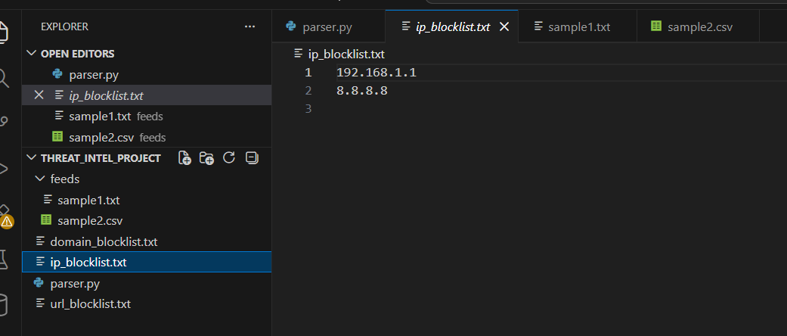
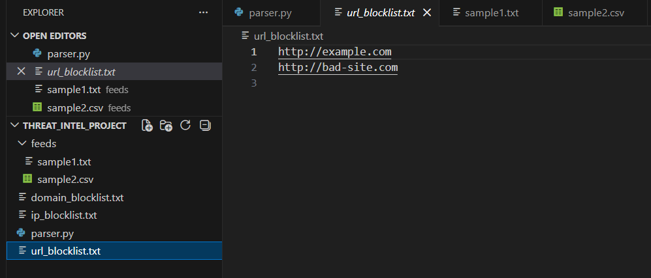
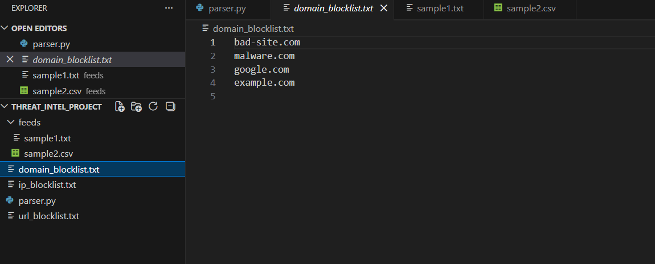
Figure 8.3: Generated Blocklist File

7. System Execution
The project is executed using the command-line interface. The user runs the Python script, and the system processes all steps automatically.
Command used:
python parser.py
The system displays output in stages, including normalized data, correlated results, and confirmation of blocklist generation.
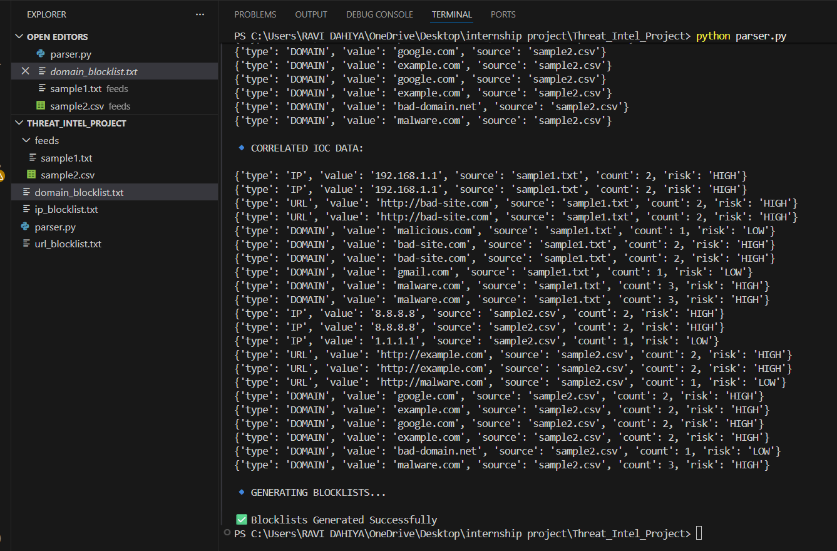
Figure 8.4: Project Execution in Terminal
8. Final Output and Results
The final output of the system includes structured IOC data, correlated indicators with risk levels, and generated blocklists. This output provides useful insights into potential threats and helps in improving cybersecurity defenses.
The implementation demonstrates how raw threat data can be transformed into actionable intelligence using simple rule-based techniques.
9. Results and Findings
The Threat Intelligence Aggregator project successfully processes raw threat data and converts it into meaningful and actionable intelligence. The system was tested using multiple input files containing various Indicators of Compromise (IOCs) such as IP addresses, domain names, and URLs. The results demonstrate that the system is capable of extracting, organizing, and analyzing threat data effectively.
During execution, the system first displayed normalized IOC data in a structured format. Each indicator was clearly categorized by type, value, and source. This structured representation improved readability and ensured that data from different sources could be easily compared and analyzed. The normalization process worked accurately for both TXT and CSV file formats.
The correlation module produced significant findings by identifying repeated indicators across multiple data sources. Indicators that appeared more than once were assigned a HIGH risk level, while others were marked as LOW risk. This helped in distinguishing potentially harmful indicators from less critical ones. For example, repeated entries such as certain IP addresses, URLs, and domain names were successfully detected and flagged as high-risk threats.
One of the key outcomes of the system is the generation of blocklists. The project created separate blocklist files for IPs, URLs, and domains. Only high-risk indicators were included in these files, ensuring that the output remains relevant and focused. This selective filtering demonstrates the effectiveness of the correlation logic in prioritizing threats.
The final output confirms that the system can handle multiple data formats, perform automated analysis, and generate useful security outputs without the need for complex algorithms. The results highlight the importance of frequency-based threat detection in cybersecurity. The system also proved to be efficient in processing data within a short time, making it suitable for real-time or near real-time applications. Additionally, the modular design of the project allows easy scalability and future enhancements. Overall, the project achieved its objective of transforming raw threat intelligence into structured, prioritized, and actionable data suitable for real-world applications.

10. Security Recommendations
Based on the results and analysis of the Threat Intelligence Aggregator project, several important security recommendations can be derived to enhance the overall cybersecurity posture of an organization. The project demonstrates how identifying and analyzing Indicators of Compromise (IOCs) can help in proactive threat prevention.
Firstly, organizations should regularly update and maintain blocklists generated from threat intelligence systems. High-risk IP addresses, domains, and URLs identified through correlation should be immediately blocked at firewalls, intrusion detection systems, and web filters to prevent malicious access.
Secondly, it is recommended to integrate multiple threat intelligence sources instead of relying on a single data feed. Collecting data from various sources increases the chances of identifying repeated and high-risk indicators, thereby improving detection accuracy and reliability.
Another important recommendation is to automate the process of threat detection and response. Manual analysis can be time-consuming and prone to errors, whereas automated systems like this project can quickly process large volumes of data and generate actionable insights in real time.
Organizations should also implement continuous monitoring of network traffic and system logs. By comparing real-time data with generated blocklists, suspicious activities can be detected and mitigated at an early stage before causing significant damage.
Additionally, maintaining proper data validation and filtering mechanisms is essential to avoid false positives. Not all repeated indicators are necessarily malicious, so further verification and contextual analysis should be performed before taking strict actions.
Regular updates and maintenance of the system are also necessary to ensure that the detection mechanisms remain effective against evolving cyber threats. Security policies should be reviewed and updated periodically based on new threat intelligence findings.
Finally, user awareness and training play a crucial role in cybersecurity. Employees should be educated about safe browsing practices, phishing attacks, and the importance of following security guidelines. A combination of technical measures and human awareness can significantly strengthen the overall security framework.

11. Learning Outcomes
The development of the Threat Intelligence Aggregator project provided valuable learning experiences in the field of cybersecurity and programming. Through this project, various technical and analytical skills were developed, which are essential for real-world security applications.
One of the key learning outcomes was understanding the concept of Indicators of Compromise (IOCs) and their importance in identifying potential cyber threats. The project helped in gaining practical knowledge of how IP addresses, domain names, and URLs can be analyzed to detect malicious activities.
The project also enhanced programming skills, particularly in Python. Concepts such as file handling, regular expressions, and data structures were applied effectively to extract and process threat data. This hands-on experience improved problem-solving abilities and logical thinking.
Another important learning outcome was the implementation of data normalization and correlation techniques. Converting unstructured data into a structured format and identifying repeated indicators provided insights into how raw data can be transformed into meaningful information. This is a critical concept in threat intelligence and data analysis.
The development process also highlighted the importance of automation in cybersecurity. By automating the extraction, analysis, and blocklist generation, the project demonstrated how manual efforts can be reduced while improving efficiency and accuracy.
Additionally, the project improved understanding of how security tools and systems work in real-world scenarios. The concept of generating blocklists and using them to prevent malicious access is widely used in firewalls and intrusion detection systems.
The project also emphasized the significance of proper testing and validation. Identifying errors, modifying input data, and verifying outputs helped in ensuring that the system works correctly under different conditions.
Overall, the project provided a strong foundation in cybersecurity concepts, programming practices, and data analysis techniques. It also enhanced the ability to design and implement practical solutions for real-world security challenges, making it a valuable learning experience.

12. Conclusion
The Threat Intelligence Aggregator project successfully demonstrates how raw and unstructured threat data can be transformed into meaningful and actionable intelligence using a simple rule-based approach. The system effectively extracts Indicators of Compromise (IOCs) such as IP addresses, domain names, and URLs from multiple data sources and processes them in a structured manner.
The implementation of normalization and correlation techniques plays a crucial role in improving data clarity and identifying potential threats. By analyzing the frequency of indicators, the system is able to classify them into different risk levels, which helps in prioritizing security actions. This approach highlights the importance of data analysis in modern cybersecurity practices.
One of the major achievements of the project is the automatic generation of blocklists. These blocklists contain only high-risk indicators, making them highly relevant and useful for real-world security applications. Such outputs can be directly utilized in firewalls, intrusion detection systems, and web filtering tools to prevent malicious activities.
The project also emphasizes the effectiveness of automation in handling cybersecurity tasks. Manual analysis of large volumes of threat data can be time-consuming and inefficient, whereas automated systems like this provide faster and more accurate results. This makes the solution suitable for practical environments where timely threat detection is critical.
Although the system is based on simple logic, it provides a strong foundation for understanding how threat intelligence systems work. The modular design of the project allows easy expansion and integration with advanced technologies such as real-time data feeds and machine learning techniques.
In conclusion, the project achieves its objective of converting raw threat data into structured, prioritized, and actionable outputs. It not only demonstrates important cybersecurity concepts but also provides a practical solution that can be enhanced further for real-world applications. Overall, the project reflects a successful combination of programming, data analysis, and security principles.

13. Future Enhancements
Although the Threat Intelligence Aggregator project successfully performs data extraction, correlation, and blocklist generation, there are several enhancements that can be implemented to improve its functionality and make it more suitable for real-world cybersecurity environments.
One of the major enhancements would be the integration of real-time threat intelligence feeds. Currently, the system processes static input files, but connecting it to live data sources such as security APIs would allow continuous monitoring and automatic updates of threat data. This would significantly improve the effectiveness and relevance of the system.
Another important improvement is the use of machine learning techniques for advanced threat detection. Instead of relying only on frequency-based analysis, machine learning models can be trained to identify complex patterns and detect previously unknown threats. This would enhance the accuracy of risk classification and reduce false positives.
The project can also be extended by developing a graphical user interface (GUI). A user-friendly interface would make the system more accessible, allowing users to upload files, view results, and manage blocklists easily without using command-line operations.
Integration with security tools such as firewalls and intrusion detection systems is another valuable enhancement. Automatically updating blocklists in these systems would enable real-time protection against malicious activities and reduce manual intervention.
Additionally, the system can be improved by supporting more file formats such as JSON, XML, and log files. This would increase compatibility with different data sources and expand the usability of the project.
Another enhancement involves implementing a database to store historical threat data. This would allow trend analysis, reporting, and better decision-making based on past incidents.
Finally, performance optimization and scalability improvements can be made to handle large volumes of data efficiently. Techniques such as parallel processing and optimized data structures can be used to improve speed and system performance.
Overall, these enhancements would transform the project from a basic prototype into a more advanced and scalable threat intelligence system suitable for real-world cybersecurity applications.
14. References
The following references were used during the development of the Threat Intelligence Aggregator project. These sources provided guidance on cybersecurity concepts, Python programming, and threat intelligence techniques.
- Stallings, William, Network Security Essentials: Applications and Standards, Pearson Education.
- Scarfone, Karen and Mell, Peter, Guide to Intrusion Detection and Prevention Systems (IDPS), National Institute of Standards and Technology (NIST).
- OWASP – Resources on web security and threat intelligence practices.
- SANS Institute – Materials on threat detection and incident handling.
- Python Software Foundation, Python Documentation – Official documentation for Python programming concepts and libraries.
- MITRE ATT&CK – Framework for understanding adversary tactics and techniques.
- Various online tutorials and documentation related to file handling, regular expressions, and data processing in Python.

